**Chosen chapters – computational imaging**

**Costa da Quinta, Joao Filipe**

**Exercice 1:**

* 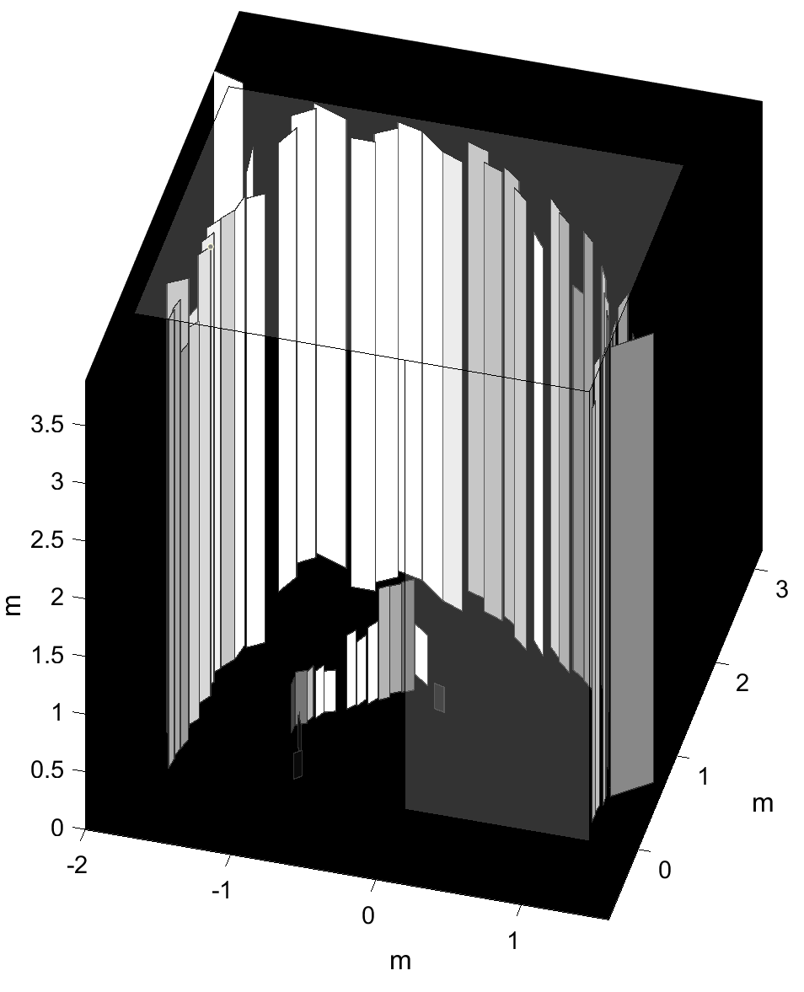run the matlab code, here is the result:

It was fully capable of detecting the hight of the hidden room, as well as its walls.

It was also capable of detecting an object in the middle of the room, and its general form/shape!

This is done my sending a laser signal to specific points of the visible wall (a), the signal is then reflected to the room that isn’t visible (b) once this signal gets in contact with objects in the room, it is reflected back to the visible wall (a), and finally to the source of the signal. Then we measure the travail time for the signal since it was sent until it is received, this way we can approximate the distance of the hidden objects inside the secret room (b). By doing this many times one can compute an approximation of the dimensions of the secret room, as well as the objects hidden inside!

**Exercise 2:**

The acquisition time doesn’t seem to impact the time elapsed, however it does impact the results of the reconstruction, for instance:

* Empty room layout had the most accurate reconstruction with 60s
* Staircase inside room layout had the most accurate reconstruction with 30s
* Mannequins room layout had the most accurate reconstruction with 20s

As we can see there is not a perfect solution, depending on the layout the corresponding optimal acquisition times might differ.